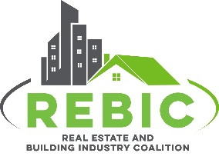
April 8, 2026
UNDERSTANDING
THE HOMESTEAD EXPEMPTION

In North Carolina, as in many other states, there is a statutory provision that is often referred to as the “homestead exemption,” that provides property tax relief for certain individuals. This document will give you a deeper understanding of this very important provision that REBIC lists as one of our key areas of focus to advocate for better housing outcomes.
Overview: The homestead exemption is designed to lower property taxes for homeowners on their primary residence. It allows eligible residents to exclude a portion of their home’s assessed value from taxation, which can significantly reduce annual property tax bills. This exemption is a part of a broader set of property tax relief programs available to seniors, disabled residents, veterans, and other qualifying groups.
Eligibility:
Here’s how you can qualify for the exemption.
- You must own and occupy the property as your primary residence.
- Programs have age, disability, or income requirements, particularly for seniors or low-income residents.
- Disabled veterans may qualify for additional exclusions.
- The exemption is not automatic, and homeowners must apply to receive the tax benefit. - Deadline to apply is June 1st.

Benefits:
- For elderly or disabled homeowners, the exemption can reduce taxable value by up to $25,000 or 50% of the property’s assessed value.
- Low-income residents may defer property taxes that exceed 4-5% of their annual income.
- Disabled veterans can exclude a significant portion of their home’s assessed value from taxation.

These programs are managed at the county level so here are links with detailed information from each county:

Mecklenburg County Iredell County Cabarrus County
Union County Gaston County Haywood County

